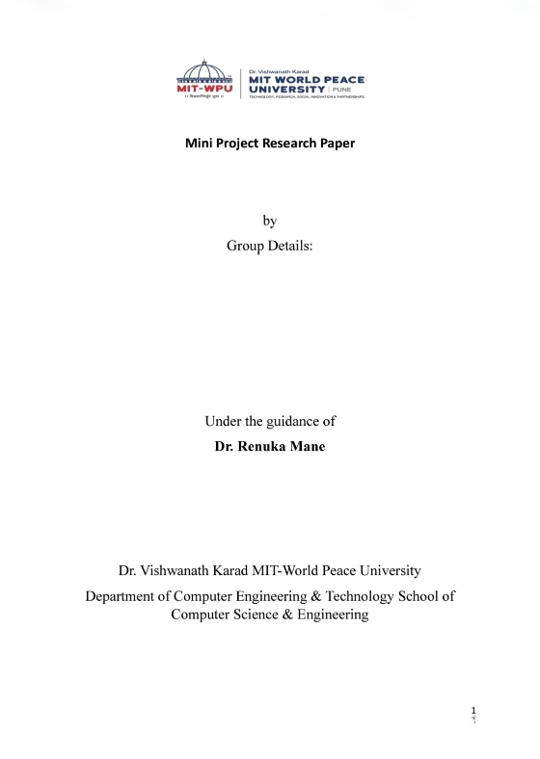
Sonal Bulusu - 1262253393
Rishika Agarwal - 1262251622
Smriti Agarwal - 1262252797
Nehali Sawarkar - 1262253570

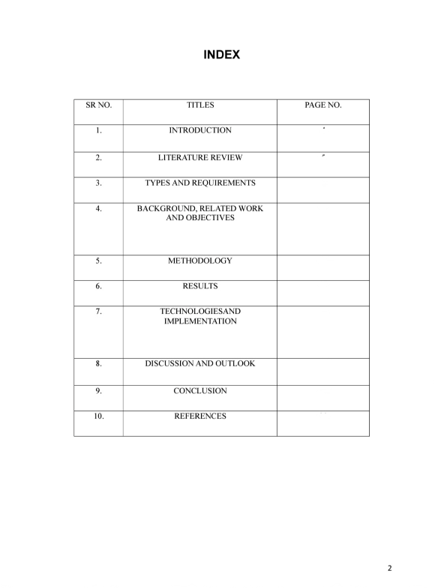
22
21
19
17
11
9
8
6
5
4

MINI PROJECT REPORT
Title: Space Mission Survival Game (Console-Based Simulation)

Abstract
The Space Mission Survival Game is a console-based interactive simulation developed using the C programming language. The project is designed to replicate a simplified yet realistic space mission environment where a player must strategically manage limited resources while navigating through unpredictable and hazardous space conditions.
The primary objective of the system is to simulate survival decision-making under constraints, where the player must maintain three critical resources—fuel, oxygen, and crew health—while attempting to reach a target distance of 100 units. The game introduces dynamic, randomly generated events that mimic real-world space challenges such as asteroid impacts, oxygen leakage, equipment malfunction, radiation exposure, and cosmic disturbances.
Each event presents multiple decision options, and each choice has a direct and measurable impact on the system’s state. The consequences of decisions are designed to reflect real-world trade-offs between safety, efficiency, and risk. This introduces a layer of strategic thinking, where players must balance short-term gains with long-term survival.
The system is structured into multiple levels of increasing difficulty. As the player progresses, the frequency and severity of events increase, thereby simulating escalating mission complexity. A reward-based level-up system is also implemented to provide temporary relief and maintain gameplay balance.
From a technical perspective, the project demonstrates the application of structured programming principles, including modular design using functions, pointer-based parameter passing for efficient memory handling, loop control structures for continuous gameplay, and conditional branching for decision logic. The use of pseudo-random number generation ensures unpredictability, making each gameplay experience unique.
Overall, the project successfully combines programming fundamentals with simulation logic to create an engaging educational tool. It highlights the importance of decision-making, resource optimization, and system design in solving real-world problems.

1.Introduction

In modern computing, simulation-based systems play a significant role in modeling real-world environments and enabling users to interact with complex scenarios in a controlled manner. These systems are widely used in domains such as aviation training, military operations, healthcare, and space exploration.
This project focuses on the development of a Space Mission Survival Game, a console-based simulation designed to mimic the challenges faced during a space expedition.
Unlike traditional games that rely heavily on graphics, this project emphasizes logic, decision-making, and algorithmic thinking. The entire system is implemented using the C programming language, which provides a strong foundation for understanding low-level operations and efficient memory management.
The gameplay revolves around three essential resources:
- Fuel, which determines the ability of the spacecraft to move forward
- Oxygen, which is critical for sustaining life
- Health, which represents the physical condition of the crew
The player must continuously monitor these resources while responding to randomly generated events. Each decision affects the overall mission outcome, making the game highly interactive and engaging.
The introduction of multiple difficulty levels ensures a gradual increase in complexity, allowing players to adapt and improve their strategies over time.
This project not only demonstrates programming skills but also highlights the importance of strategic planning, risk assessment, and resource allocation in achieving mission objectives.

2. Literature Review
Simulation-based gaming and decision-support systems have been extensively studied in the field of computer science and education. These systems are known for their ability to provide experiential learning by allowing users to interact with dynamic environments.
Several studies suggest that simulation games enhance cognitive abilities such as:
- Analytical thinking
- Problem-solving
- Decision-making under uncertainty
- Resource optimization
In the context of survival-based simulations, resource management is a key component. Systems that require users to manage limited resources while facing unpredictable challenges are particularly effective in developing strategic thinking skills.
Console-based simulations, despite lacking graphical interfaces, are widely used in academic settings because they focus on the core logic of the system. They allow students to understand how algorithms and data structures work behind the scenes without the complexity of graphical programming.
Random event generation is another important aspect of simulation systems. It introduces variability and unpredictability, ensuring that no two sessions are identical. This enhances user engagement and mimics real-world uncertainty.
The concept of level-based progression is commonly used in games to gradually increase difficulty. This approach helps in maintaining user interest while providing a sense of achievement.
This project builds upon these principles by integrating resource management, random events, and progressive difficulty into a single system.

3. Types and Requirements

3.1 Type of System
The Space Mission Survival Game can be classified as:
• A console-based interactive application
• A single-player simulation system
• A decision-driven game model
This system allows the user to interact through a text-based interface where decisions directly affect the outcome of the game. It simulates real-life survival situations in space in a simplified manner.

3.2 Functional Requirements
The system is designed to perform the following functions:
- Display a menu-driven interface for user interaction
- Provide clear instructions for gameplay
- Generate random mission events dynamically
- Accept user input for making decisions
- Update resources such as fuel, oxygen, and health
- Maintain game progression and level transitions
- Display the final mission result (success or failure)
These functions ensure that the game runs smoothly and provides an engaging experience to the user.

3.3 Non-Functional Requirements
The system must satisfy the following conditions:
• Efficiency: The program should execute quickly without delays
• Reliability: The system should give correct and consistent results
• Usability: The interface should be simple and easy to understand
• Maintainability: The code should be well-structured and easy to modify
• Portability: The program should run on different systems without issues
These requirements improve the overall quality and performance of the system.

3.4 System Constraints
The system works under certain limitations:
• The game is limited to a console-based interface (no graphics)
• It depends on user input for decision-making
• Random events may vary each time the game is played
• Limited system resources like memory and processing power
• No external database or internet connection is used
These constraints define the boundaries within which the system operates.

3.5 Assumptions
The following assumptions are made while designing the system:
• The user has basic knowledge of using a computer
• The system environment supports C programming execution
• Inputs provided by the user are valid and within expected range
• The user understands the game instructions properly
These assumptions help simplify the design and implementation of the system.

4. Background, Related Work, and Objectives
4.1 Background
Space missions are inherently complex and require continuous monitoring of resources and systems. Astronauts must make critical decisions under pressure, often with limited information and time.
This project attempts to simulate such conditions in a simplified environment, allowing users to experience the challenges of space survival.

4.2 Related Work
Existing systems in this domain include:
- Survival simulation games
- Space exploration games
- Strategy-based decision systems
These systems emphasize planning, adaptability, and risk management.

4.3 Objectives
The key objectives of this project are:
- To design and develop a simulation game using C
- To implement decision-based gameplay mechanics
- To simulate real-world survival challenges
- To demonstrate core programming concepts
- To enhance logical and analytical thinking

5. Methodology (DETAILED)
5.1 System Initialization
At the start of the game, all resources are initialized to maximum values to provide a fair starting point for the player.

5.2 Game Loop Execution
The core of the system is a loop that continues until the mission is completed or failed.
Each iteration includes:
- Event generation
- User input
- Resource update

5.3 Random Event Generation
Random numbers are used to generate events. This ensures:
- Unpredictability
- Replayability
- Realistic simulation

5.4 Decision Processing
Each event provides three choices:
- Optimal (low risk)
- Moderate (balanced)
- Risky (high risk)
Each choice affects resources differently.

5.5 Level Progression System
The game includes three levels:
- Level 1: Basic scenarios
- Level 2: Moderate challenges
- Level 3: Critical emergencies

5.6 Resource Impact Calculation
Resources are updated using formulas based on:
- Choice selected
- Current level

5.7 Termination Conditions
The system continuously checks:
- If resources are depleted → Mission failed
- If distance reached → Mission success

6. Results (Detailed Analysis)

6.1 Observed Behavior
During the execution of the Space Mission Survival Game, the following behaviors were observed:
• Dynamic Gameplay:
Each time the game runs, different mission events are generated randomly. This ensures that the gameplay is not repetitive and provides a unique experience every time. The unpredictability keeps the user engaged and interested.
• Real-time Updates:
The system continuously updates important resources such as fuel, oxygen, and health after every decision made by the user. This helps the player understand the immediate impact of their choices and plan future actions accordingly.
• Increasing Difficulty Level:
As the game progresses, the difficulty level gradually increases. Challenges become more complex, and resource management becomes more critical. This progression makes the game more exciting and realistic.
• User Interaction:
The game actively involves the user by requiring inputs at every stage. This interaction improves engagement and gives the player a sense of control over the mission.
• Decision Impact Visibility:
Every decision taken by the user directly affects the outcome of the mission. The results of actions are clearly visible, helping users understand cause-and-effect relationships.

6.2 Benefits
The development and execution of this system provide several advantages:
• Improves Programming Skills:
The project helps in strengthening core programming concepts such as loops, conditional statements, functions, and handling user input. It also improves logical thinking and coding efficiency.
• Enhances Decision-Making Ability:
Since the game is decision-based, users must think carefully before making choices. This improves analytical thinking and decision-making skills.
• Teaches Resource Optimization:
Players learn how to manage limited resources like fuel and oxygen effectively. This concept is important not only in games but also in real-life problem-solving.
• Encourages Problem-Solving:
Users face different scenarios that require quick thinking and solutions. This enhances problem-solving abilities.
• Provides Practical Learning:
Instead of only theoretical knowledge, this project gives hands-on experience in building and understanding a working system.

6.3 Challenges
While developing and running the system, the following challenges were encountered:
• Designing Balanced Gameplay:
It was difficult to maintain a proper balance between difficulty and playability. If the game is too easy, it becomes boring; if too difficult, it becomes frustrating.
• Managing Multiple Variables:
Handling multiple resources like fuel, oxygen, and health simultaneously required careful planning to avoid errors and inconsistencies.
• Avoiding Repetition in Events:
Creating a variety of random events without repetition was challenging. Repetitive events can reduce user interest.
• Handling User Input Errors:
Ensuring that the program correctly handles invalid or unexpected user inputs required additional validation checks.
• Maintaining Game Flow:
Keeping the game smooth and continuous without logical breaks or errors was another important challenge.

6.4 Improvements Suggested
Based on observations, the following improvements can be made:
• Add a graphical user interface (GUI) for better visual experience
• Include sound effects and animations to enhance gameplay
• Introduce multiple levels or missions for extended gameplay
• Add scoring system and leaderboard
• Improve randomness for more diverse events

6.5 Overall Outcome
The system successfully demonstrates a functional simulation game that is interactive, educational, and engaging. It effectively combines programming concepts with practical implementation. The project meets its objectives and provides a strong foundation for further development and enhancements.

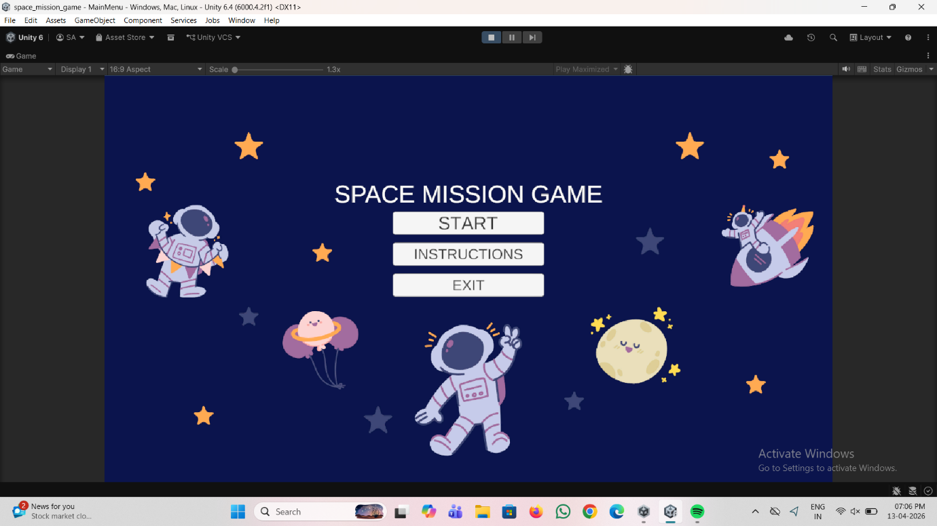
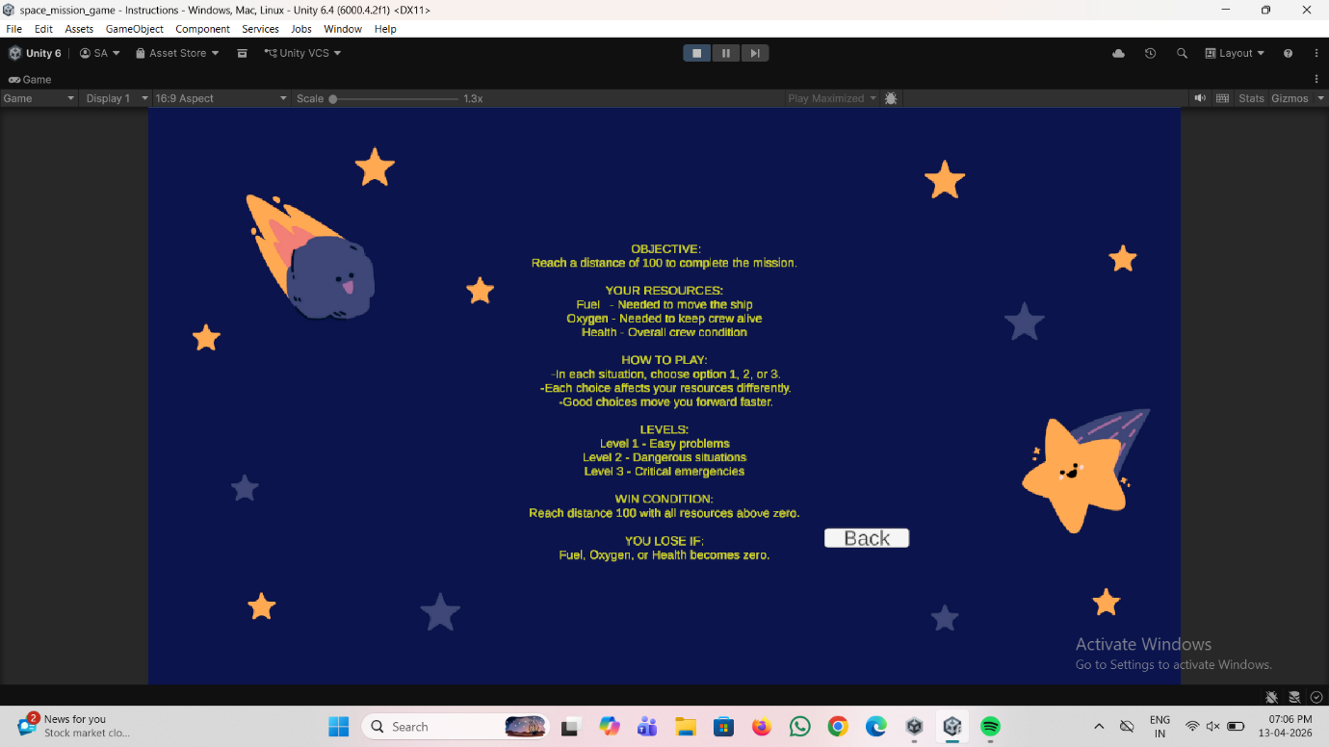
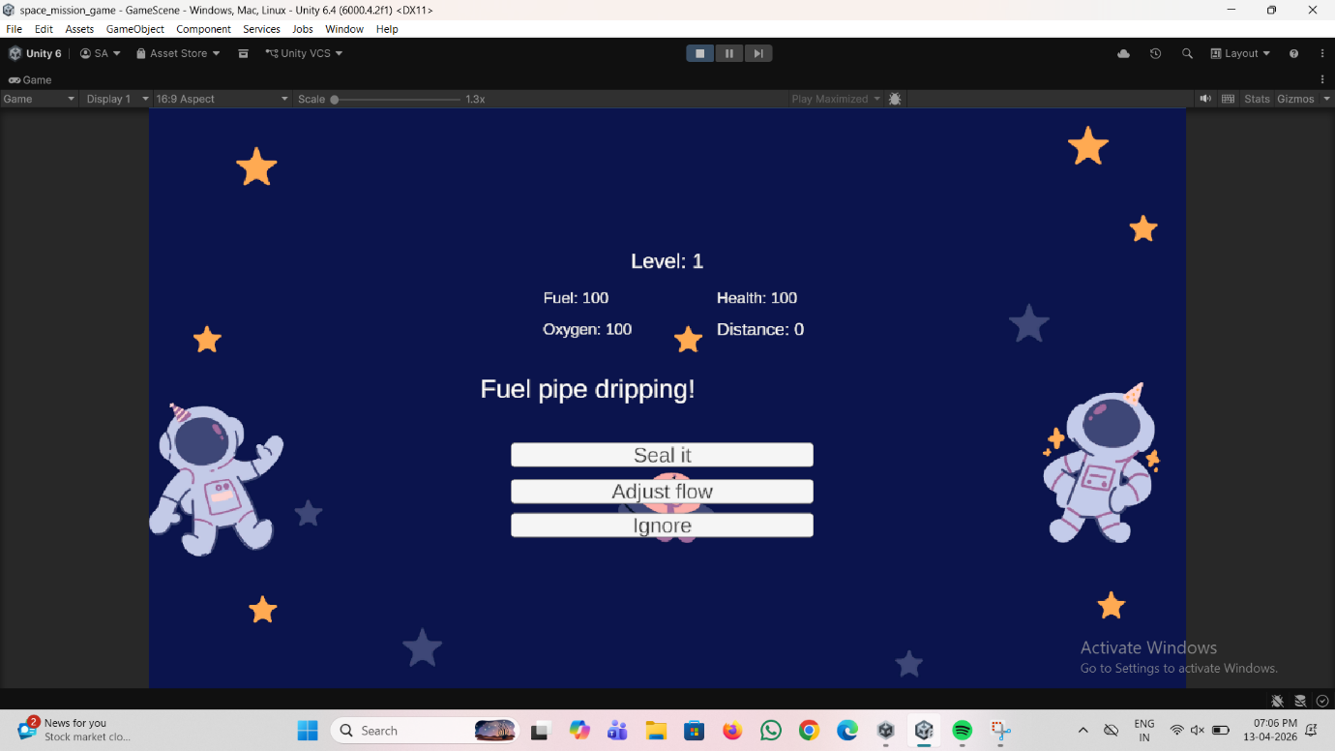

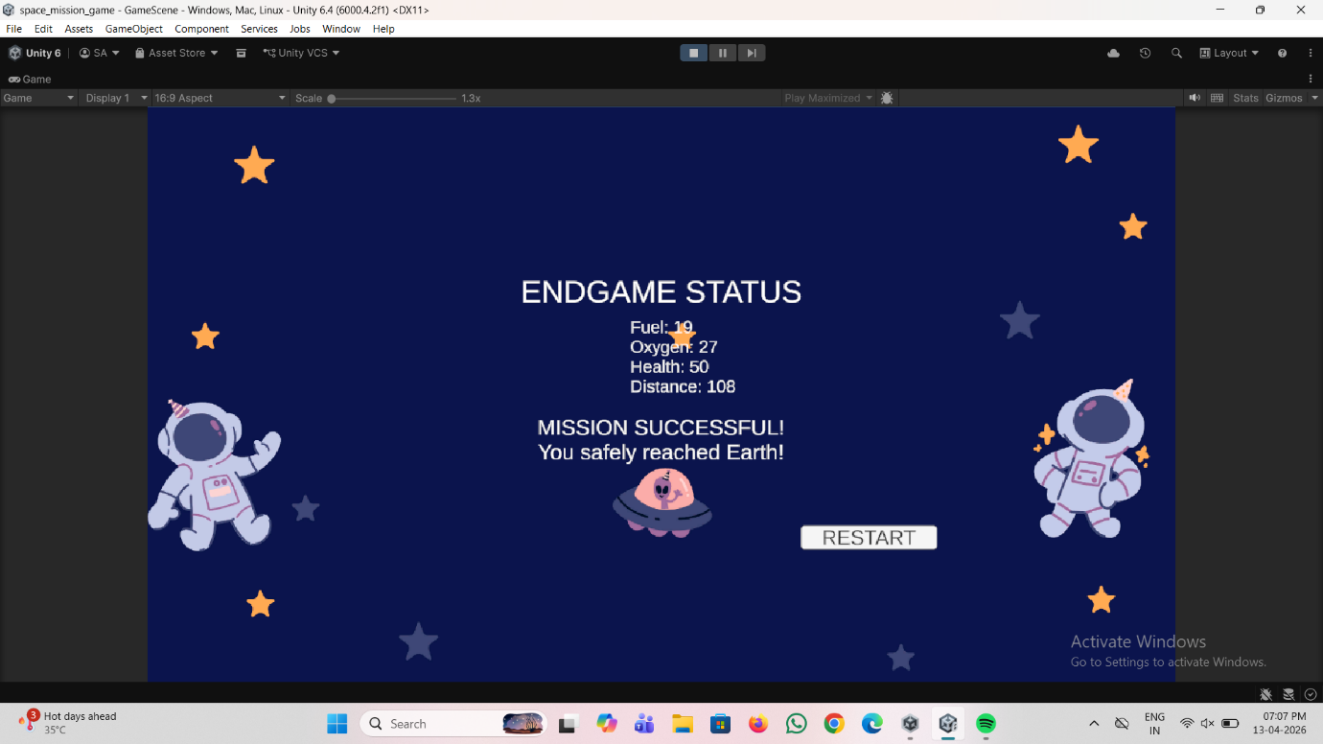

7. Technologies and Implementation

7.1 Programming Language
• C Programming Language:
The entire system is developed using the C language. C is a powerful and efficient programming language widely used for system-level and application development. It provides better control over memory and execution speed, making it suitable for console-based applications like this game.
C also helps in understanding core programming concepts such as variables, loops, conditions, and functions, which are essential for building logical programs.

7.2 Libraries Used
The following standard libraries are used in the implementation:
• stdio.h (Standard Input Output Library):
This library is used for handling input and output operations. Functions like printf() and scanf() are used to display messages and take input from the user.
• stdlib.h (Standard Library):
This library provides functions for memory management, random number generation, and program control. The rand() and srand() functions are used to generate random mission events.
• time.h (Time Library):
This library is used to seed the random number generator using the current system time. It ensures that different random values are generated each time the program runs.

7.3 Concepts Used
The project makes use of several important programming concepts:
• Functions:
Functions are used to divide the program into smaller, manageable parts. Each function performs a specific task such as displaying the menu, handling events, or updating resources. This improves code readability and reusability.
• Pointers:
Pointers are used to store memory addresses and allow direct manipulation of variables. They help in passing values efficiently between functions and managing data effectively.
• Loops:
Loops such as while and for are used to repeat actions in the game. For example, the game continues running until a certain condition (win or loss) is met.
• Conditional Statements:
if, if-else, and nested conditions are used to make decisions in the game based on user input and game state.
• Randomization:
Random number generation is used to create unpredictable events in the game. This ensures that each gameplay session is unique and engaging.

7.4 Implementation Details
The system is implemented using a structured approach:
• The program starts with a main menu that allows the user to start or exit the game
• Instructions are displayed before gameplay begins
• The game enters a loop where events are generated randomly
• The user is prompted to make decisions at each stage
• Based on decisions, resources like fuel, oxygen, and health are updated
• The game continues until a success or failure condition is reached
• Finally, the result of the mission is displayed

7.5 System Workflow
The working of the system can be summarized as follows:
- Start the program
- Display menu and instructions
- Initialize resources (fuel, oxygen, health)
- Generate random events
- Accept user decision
- Update resources
- Check game condition (continue / end)
- Display final result
This structured workflow ensures smooth execution and easy understanding of the system.

8. Discussion and Outlook

8.1 Discussion
The Space Mission Survival Game successfully demonstrates how simple programming techniques and algorithms can be used to simulate complex real-world scenarios. Although the system is developed using basic C programming concepts, it is capable of creating an engaging and interactive environment.
The use of decision-making logic, loops, and random event generation allows the system to mimic real-life space mission challenges such as resource management, risk assessment, and survival strategies. This shows that even a console-based application can effectively represent dynamic and unpredictable situations.
However, the system has certain limitations:
• Lack of Graphical Interface:
The game is purely text-based, which may reduce visual appeal and user engagement compared to modern graphical games.
• No Persistent Storage:
The system does not save user progress or game data. Every time the program is restarted, the game begins from the initial state.
• Limited Complexity:
The logic is relatively simple and may not fully represent real-world mission complexities.
• Basic User Interaction:
The interaction is limited to keyboard input without advanced controls or feedback mechanisms.
Despite these limitations, the system serves as a strong foundation for understanding simulation-based programming.

8.2 Outlook (Future Scope)
There are several opportunities to enhance the system and make it more advanced and user-friendly:
• Graphical User Interface (GUI):
Introducing a GUI using tools like graphics libraries or frameworks would improve the visual experience and make the game more interactive.
• Data Storage and Saving Feature:
Implementing file handling can allow saving and loading of game progress, making the system more practical and user-friendly.
• Advanced Game Logic:
More complex scenarios, multiple missions, and branching storylines can be added to increase realism and engagement.
• Sound Effects and Animations:
Adding audio and visual effects can make the gameplay more immersive.
• Multiplayer Mode:
Extending the system to support multiple players can increase competitiveness and user interest.
• Scoring and Ranking System:
Introducing scores, achievements, and leaderboards can motivate users to perform better.
• Integration with Advanced Technologies:
Future versions could include AI-based decision systems or simulations for more realistic gameplay.

8.3 Conclusion of Discussion
Overall, the project demonstrates that even simple programming techniques can be used to build meaningful and interactive systems. While the current implementation has limitations, it provides a solid base for further improvements and innovation.
The system has strong potential to evolve into a more advanced simulation tool with enhanced features, better user experience, and greater practical applications.

9. Conclusion

The Space Mission Survival Game successfully integrates fundamental programming concepts with simulation techniques to create an engaging, interactive, and educational system. The project effectively demonstrates how core concepts of C programming such as loops, conditional statements, functions, and randomization can be applied to develop a meaningful real-world application.
Through this system, it is evident that even a simple console-based application can simulate complex real-world environments like space missions. The game models critical aspects such as decision-making under pressure, resource management, and handling unpredictable situations. This highlights the power of logical programming in representing real-life scenarios in a simplified yet effective manner.
The project also provides practical exposure to problem-solving and system design. It helps in strengthening analytical thinking, as users must carefully evaluate situations and make decisions that directly impact the outcome of the mission. Additionally, it enhances understanding of how dynamic systems operate through continuous updates and event-driven execution.
Although the system has certain limitations such as lack of graphical interface and absence of data storage, it still fulfills its primary objective of demonstrating simulation-based learning using basic programming tools. These limitations also open opportunities for further development and improvements.
In conclusion, the project serves as a strong foundation for learning and innovation. It proves that with proper logic and structured implementation, even simple programming techniques can be used to build systems that are both functional and insightful. The Space Mission Survival Game not only meets its intended goals but also encourages further exploration in the field of game development and simulation systems.

10. References
- Kernighan, B. W., & Ritchie, D. M., The C Programming Language, Prentice Hall
- ANSI C Standard Documentation, ISO/IEC 9899: C Programming Language
- Pressman, R. S., Software Engineering: A Practitioner’s Approach, McGraw-Hill
- Schildt, H., C: The Complete Reference, McGraw-Hill
- Balagurusamy, E., Programming in ANSI C, Tata McGraw-Hill
- Gottfried, B. S., Programming with C, Schaum’s Outline Series
- Simulation System Design Concepts, Academic Notes and Study Material
- Online C Programming Tutorials and Documentation (GeeksforGeeks, TutorialsPoint)
- Random Number Generation Techniques using C Standard Library (stdlib.h)
- Console-Based Game Development Concepts and Practices

